|  |  |
| --- | --- |
| TC#1 | Verify that the homepage loads properly without any errors or broken links |
|

|  |  |  |
| --- | --- | --- |
| 1 | Open the landing page | The homepage should be launched successfully |



|  |  |  |
| --- | --- | --- |
| 2 | Verify all the links and buttons on the Home page | All the links and buttons on the Home page should be working as expected |

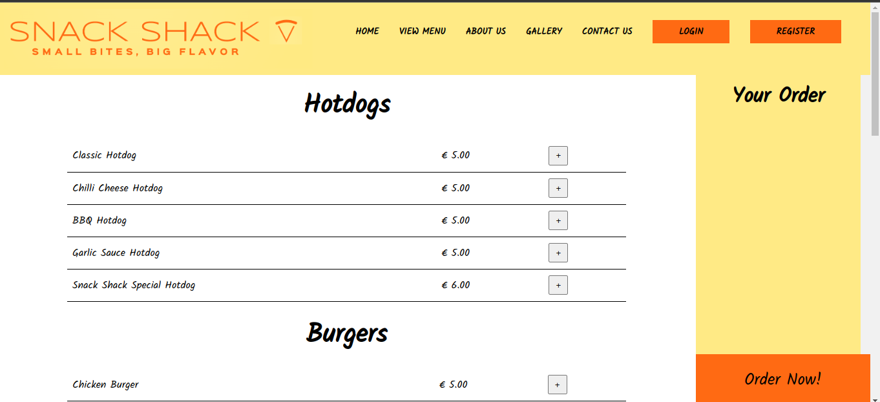





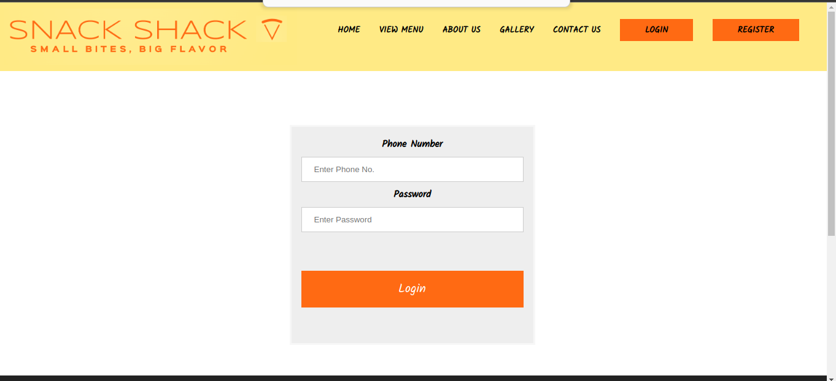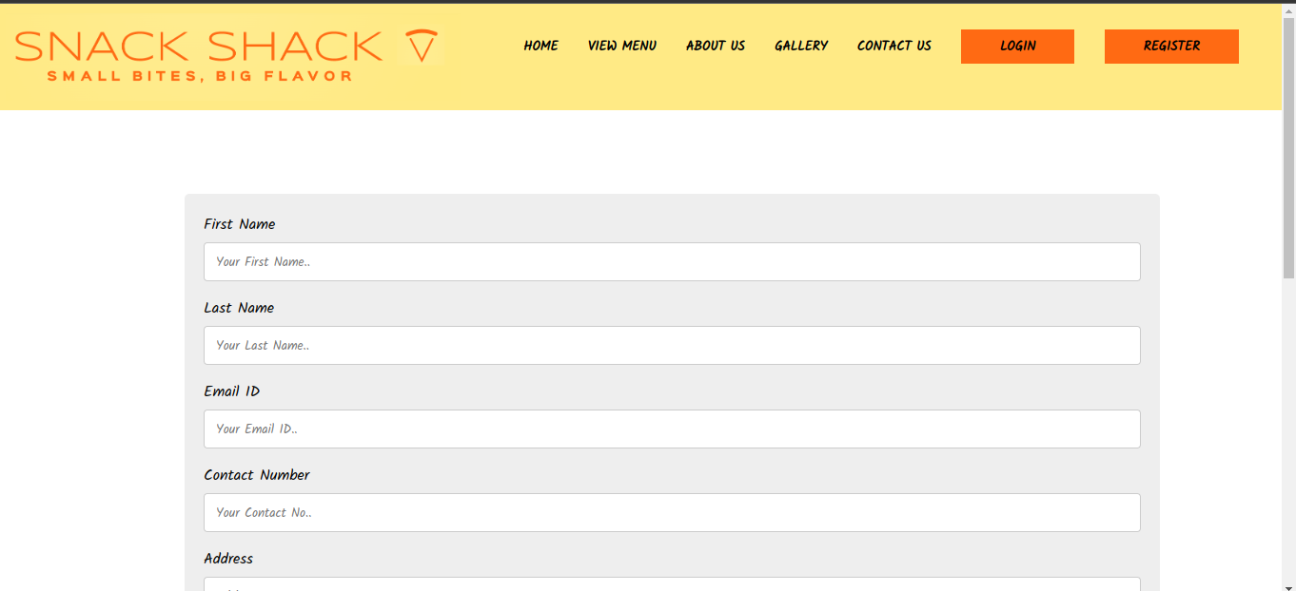

|  |  |
| --- | --- |
| TC#2 | Verify the Login form functionality |

|  |  |  |
| --- | --- | --- |
| 1 | Open the Login page | The Login page should be launched successfully |



|  |  |  |
| --- | --- | --- |
| 2 | Enter the Phone Number | The Phone Number should be entered |

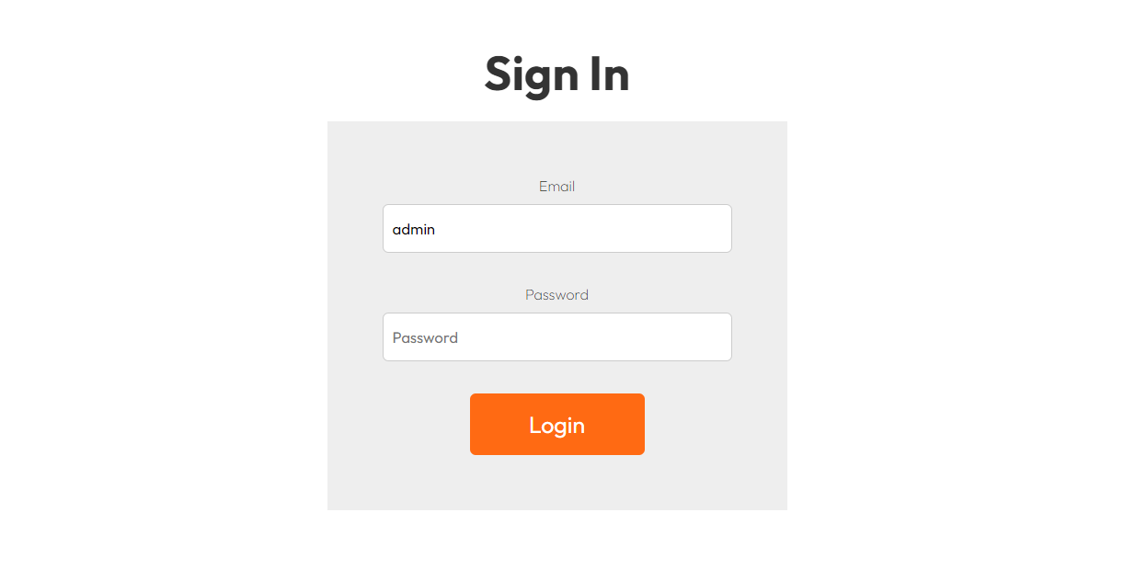

|  |  |  |
| --- | --- | --- |
| 3 | Enter the Password | The Password should be entered |

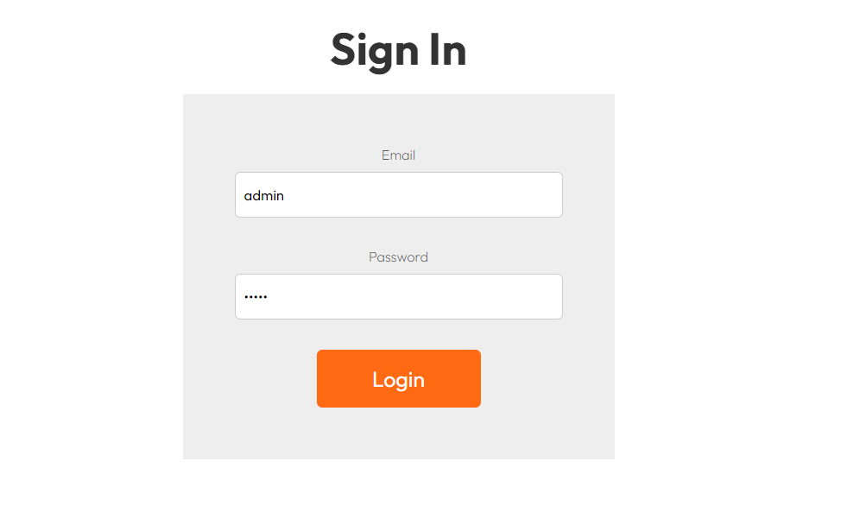

|  |  |  |
| --- | --- | --- |
| 4 | Click Login | The form should be submitted successfully |



|  |  |
| --- | --- |
| TC#3 | Negative Scenario: Validate incorrect values of the Login form |

|  |  |  |
| --- | --- | --- |
| 1 | Open the Login page | The Login page should be launched successfully |

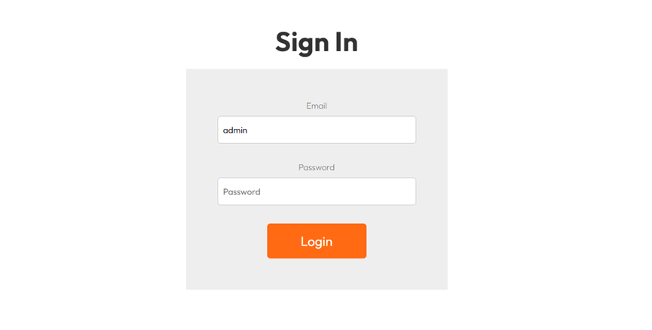

|  |  |  |
| --- | --- | --- |
| 2 | Validate by entering incorrect password values of the Login form | All incorrect validations should be as expected |

